**Context Free Presentation**

**Purpose**

Creating better visualization s for end user to read and understand the data which has been developed.

**Approach:**

The approach for this purpose is broken into two segments. First step in order to achieve the proposed objective we have to prepare the data which can be presented to the end user. The data needs to be structured and to the point for the end user to understand. For this presentation I used the keywords and job titles from previous project. The data was collected by utilizing web scraping method and then was stored as a flat file to create datasets. After the initial data was acquired we create d subsets to filter the data which will be used for visualization.

**Code Segments**

## matching words which are in the list to the dataframe.

## got a new dataframe.

Filter_Worddata <- df_BigData[ which(words %in% 'big data' |

words %in% 'aws' |

words %in% 'machine learning'|

words %in% '.net'|

words %in% 'java'|

words %in% 'sqlserver'|

words %in% 'hadoop'|

words %in% 'datawarehouse'|

words %in% 'python'|

words %in% 'oracle'|

words %in% 'sas'|

words %in% 'r'|

words %in% 'c/c++'|

words %in% 'data science'|

words %in% 'dynamodb'|

words %in% 'sql server'|

words %in% 'experimental design'|

words %in% 'mysql'|

words %in% 'agile'|

words %in% 'data mining'|

words %in% 'shell script'|

words %in% 'enterprise software'|

words %in% 'embedded software'),c('doc_id','job_title','state','words')]

nrow(Filter_Worddata)

**Visualization**

We used word Cloud library from R to visualize the keywords and some of the job titles which were relevant to the data we wanted to visualize.

**Final Result**

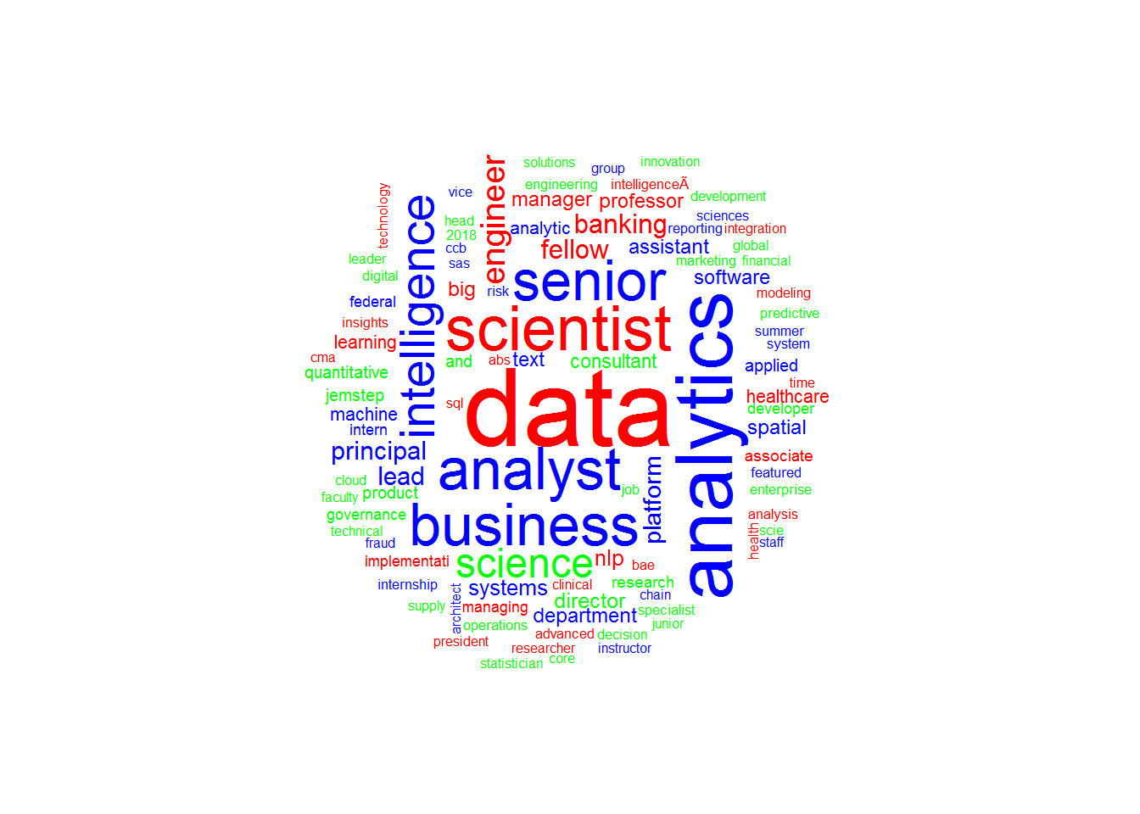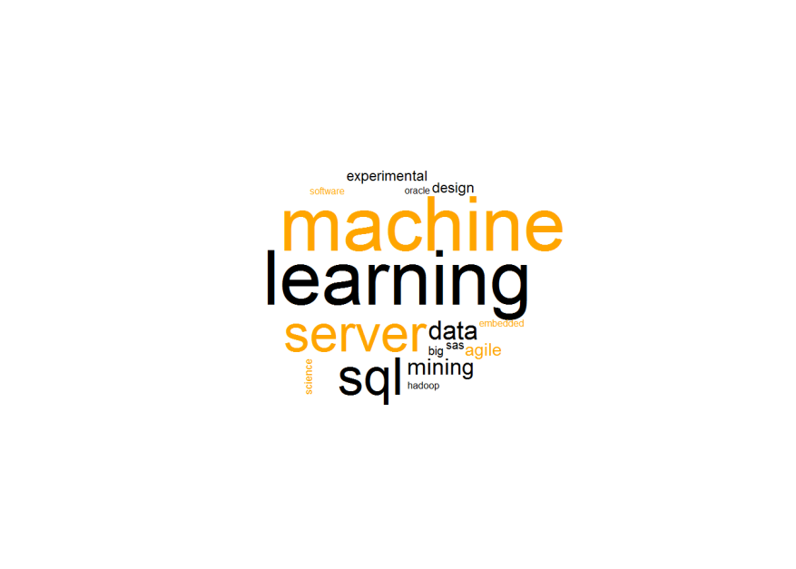

**Final Word**

This approach is simple yet very effective is visualizing data. I feel that this approach makes your data more presentable, and user friendly rather that showing boring, dull datasets which most of the end user won’t even look at. This approach could also help a developer to attract more audience to see their data findings and related work; this is just one way of presenting the data to real world with some taste and colorful visualization. Its’ simple yet stands out.